**Staff operator**

**Abstract:**

* Currently, one of the most ordinary issue faced by the employers or the students is correlated with attendance.
* Students get shortage of attendance and Employers need to pay for their leave due to several factors beyond their control as in the case of an emergency, where they might not be able to send their leave application.
* In the case of students, due to lack of coordination with the concerned authorities, Students miss the attendance of several important in-campus and off-campus activities such as events, workshops, seminars etc.

**Current System:**

* In current system, the records are maintained manually by the administrative user. The attendance is carried out in the form of hand-written registers or in online forms.
* Even the coordinator needs to maintain all the records manually. And It is also very hard work to maintain the record for the users because of more human effort.
* This system requires correct feed on input into the respective field. Suppose wrong inputs are entered, then the application could get misunderstood and rejected.
* So, the user finds the difficulty to use. The existing system is not user friendly because the retrieval of data is time consuming and data is not maintained efficiently.
* These systems need to be handled by a specialist for maintaining and updating the system which is very costly. It requires more calculations to generate the report. So, it is generated at the end of the session.
* To generate report for all calculation manually. So, there is some greater chance of errors. The faculty has to suffer through the calculation. If there is loss of report, then it may cause many issues.

**Proposed System:**

* In proposed system, the chance of losing data is not possible because data is maintained in the form of database and digitalization of student’s information.
* The information of attendance, leave and notice, which are updated into the database using a user-friendly GUI. This application is an online application which makes more flexible to access information.
* This software helpful for the department and management to create less burden in work. It is used to access the information for the authorized persons easily. The proposed system automates the existing system.

**Software Requirements**

* ENVIRONMENT: IDLE
* LANGUAGE: Python (3.8.2) or above
* DATABASE: SQLite3

## Hardware Requirements

* PROCESSOR:  Intel i3 or more
* RAM: 1GB RAM
* HARD DISK:  200 GB

**Use Case Diagram:**

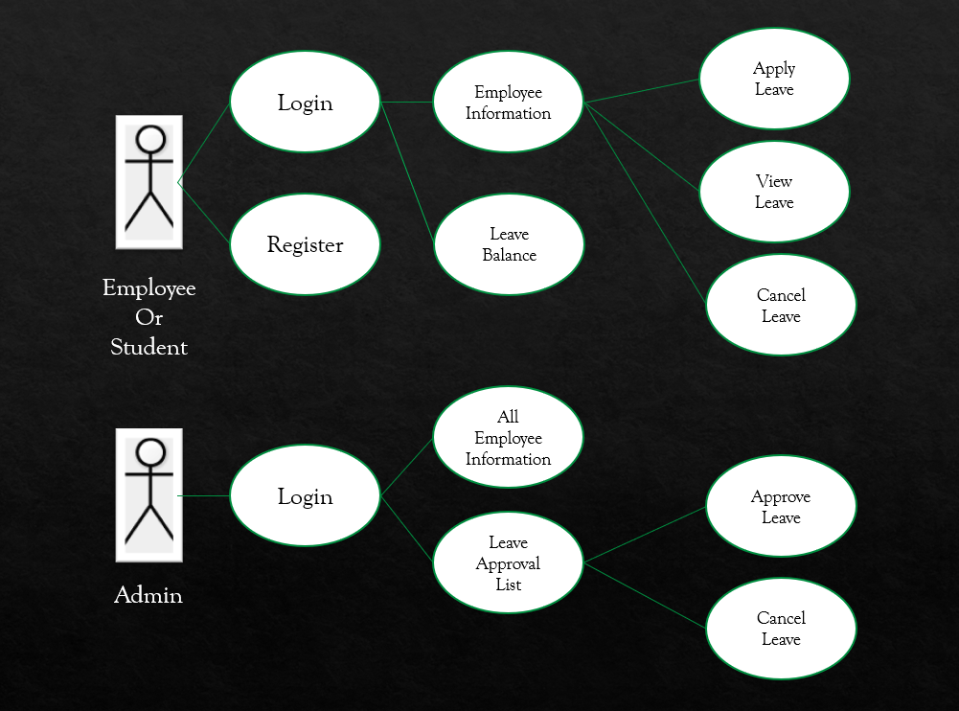

**List of Modules**

* Register Module
* Login Module
* Employee Information Module
* Apply Leave Module
* View Module
* Cancel Module
* Leave Balance Module
* Leave Approval Module

**Register Module**

* Register page provides 'ready-to-use' user interface that queries the registration details from the user which contains name, Employee id or Student id, phone number, password.
* A registration form is a list of fields that a user will input data and submit to a company or university.
* There are many reasons to fill out a registration form by person.
* Companies use registration forms to signup employers for services or other programs.

**Login Module**

* Login page provides students or employee to login the user page.
* The Login Module is a portal module which allows the users to type a user name and password to login.
* This module can be placed on any module. Tab to allow users to login to the system.

**Employee Information Module:**

* Employee Information Module deals with a ready-to-use user interface that queries the view details from the user. We can view the details which is stored in database.
* It contains the list of fields that a user will input data and submit to a company or an individual like Employee id, name, Contact number etc.
* Employee Information Module Further contain three modules:

1. Apply Leave Module:
2. Cancel Leave Module:
3. View Leave Module:
4. **Apply Leave:**

* In This Module, User can apply the leave for the specific reason.
* The Apply Leave Module will take the input from the user for necessary fields like Employee id, From which day, To which day and Total number of days.
* And User also need to select the type of the Leave from Sick Leave, Maternity Leave and Emergency Leave.
* Whenever user submit this Leave application, the admin will take the necessary decision to approve the leave or cancel the leave accordingly.

1. **View Leave:**

* In This Module, User can view the leave for the specific reason.
* Through which he/she gets to know about his/her leaves submitted earlier and accordingly schedule or manage his/her future leaves.

1. **Cancel Leave:**

* In this Module, User can cancel his/her leave if needed.
* Sometimes may be possible that User apply for the leave but later on the purpose of leave will be solved and user do not need leave in that case User can Cancel his/her leave and use that leaves for future purpose when it’s necessary.

**Leave Balance Module:**

* Through Leave Balance Module the employee is able to see the remaining leave for that particular employee.
* From this module User gets to know about the total number of leaves currently he is having in mode of Sick leave, Maternity leave and Emergency leave.
* By this module User can see the overview and can plan the future leaves accordingly.

**All Employee Information Module:**

* This Module is only accessible by the admin.
* In this Module, Admin as able to see all the information of the employees like Name of employee, Employee id, Contact number etc.
* From this module Admin get to know about all the details and take the necessary decision if needed.

**Leave Approval Module:**

* Leave Approval Module is accessible by the Admin.
* Admin can get the information about the Leave submitted by the Employee and all the necessary field that which Employee asked for leave and from which date to which date and amount of days they need for the leave.
* And accordingly, Admin can take action on it.
* Leave Approval Module Further contain two modules:

1. Approve the Leave Module
2. Cancel the Leave Module

**Approve Leave Module:**

* Admin can see the records of the employees and if seriously the leave is submitted by the employee and the amount of days, they need for the leave is smaller than their leave balance then only Admin can able to approve the leave of the employees.
* Whenever Admin approve the leave for any particular employee then that amount of leave should be deducted from the employee leave balance.

**Cancel Leave Module:**

* Admin can see the records of the employees and if the leave is not submitted for any proper or serios issue by the employee or the amount of days, they need for the leave is larger than their leave balance then only Admin can able to cancel the leave of the employees.
* Whenever Admin cancel the leave for any particular employee then that amount of leave should not be deducted from the employee leave balance.